The Electronic Structure of the α-MgH₂ Grain Boundaries

Viorel Chihaia,ª Valentin Alexiev,^{b} Dana A. Neacsu,ª and Daniel G. Angelescu ª

ª Romanian Academy, “Ilie Murgulescu” Institute of Physical Chemistry, Splaiul Independentei 202,

060021 Bucharest, Romania

^{b} Institute of Catalysis, Bulgarian Academy of Sciences, Acad G Bonchev St, Bldg. 11, 1113 Sofia, Bulgaria

e-mail vchihaia@icf.ro

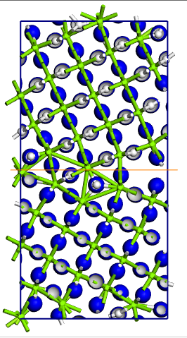
The electronic density of 5(001)[-130] tilt grain boundary for the -MgH₂
The polycrystalline materials and the ball milled powder contain a large number of extended defects like dislocations, stacking faults and grain boundaries. Some experimental data suggest that the hydrogen diffusion rate through the area with such defects is much higher than in the case of the crystalline materials. Thus, the interface diffusion could play a fundamental role in the decomposition and formation of the magnesium-based hydrides. Despite the importance of this topic in the identification of the efficient procedures for the hydrogen storage and decomposition, there is no systematic atomistic description of the hydrogen migration through the grain boundaries and the interfaces of the magnesium-based hydride materials.
In the present contribution we report the results of the DFT electronic structure calculations performed by code CASTEP,[1] in order to elucidate the structure of the grain boundaries and interfaces between the magnesium-based materials (especially, considering the polymorph α-MgH₂), and the hydrogen diffusion through these interfaces.

Key words: DFT calculations, Grain Boundary, Magnesium Hydride

Acknowledgments
The work was supported by a grant of the Romanian Ministry of Education and Research, CCCDI - UEFISCDI, project number PN-III-P2-2.1-PED-2019-4816, within PNCDI III.

References
[1] S. J. Clark, M. D. Segall, C. J. Pickard, P. J. Hasnip, M. J. Probert, K. Refson and M. C. Payne, "First principles methods using CASTEP", Zeitschrift fuer Kristallographie 220(5-6) pp. 567-570 (2005).

